**S3 bucket Creation : -**

1. 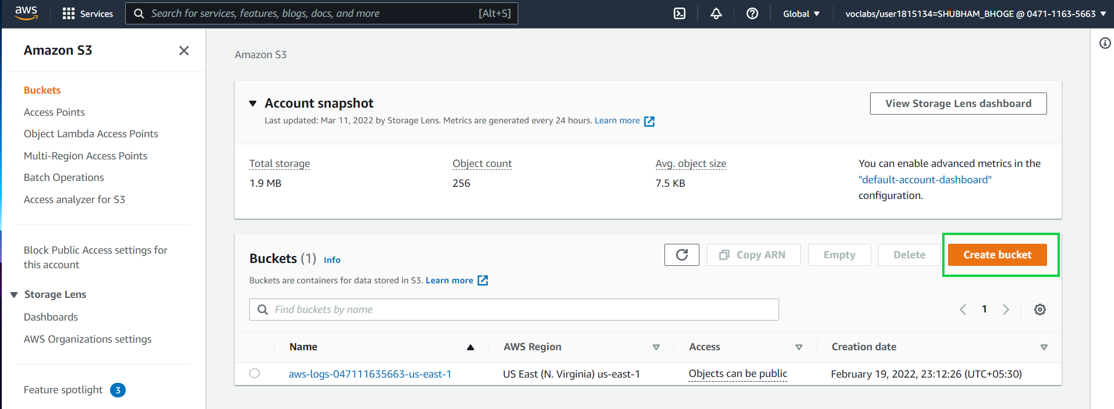Sign in to the AWS Management Console and open the Amazon S3 console. Select create bucket.

2. In **Bucket name**, enter a DNS-compliant name for your bucket.[name should be in lowercase & unique across amzon s3]

3.select **region** which you want.

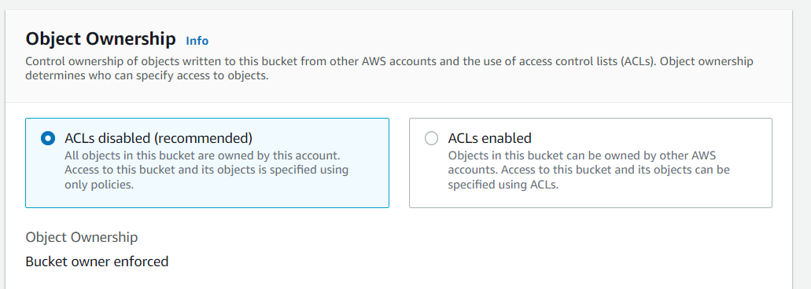4.under Object ownership. Choose **ACLs enabled** or **ACLs disabled**.

**ACLs disabled.**

**Bucket owner enforced** – ACLs are disabled, and the bucket owner automatically owns and has full control over every object in the bucket. ACLs no longer affect permissions to data in the S3 bucket. The bucket uses policies to define access control

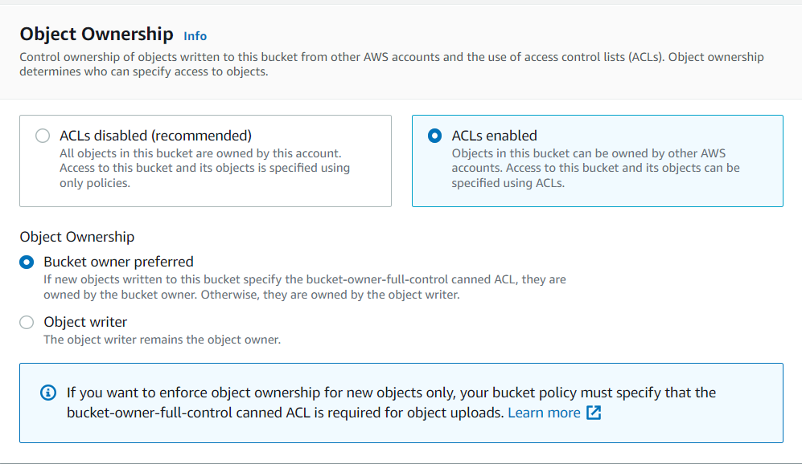

ACLS enabled has 2 options/modes : bucket owner preferred and Object writer

**Bucket owner preferred** – The bucket owner owns and has full control over new objects that other accounts write to the bucket with the bucket-owner-full-control canned ACL.

**Object writer** – The AWS account that uploads an object owns the object, has full control over it, and can grant other users access to it through ACLs.

5. In Bucket settings for Block Public Access, choose the Block Public Access settings that you want to apply to the bucket.

6. Choose Create bucket… created bucket..

**To upload an object to a bucket**

1. In the Buckets list, choose the name of the bucket that you want to upload your object to.
2. On the Objects tab for your bucket, choose Upload.
3. Under Files and folders, choose Add files.
4. Choose a file to upload, and then choose Open.Choose Upload.